An Angel Just Like Me
Diocesan Christmas Project, 2021

My daughter is now 27, so it was a real flash-back to speak to Mary Hoffman, the author of the lovely book ‘Amazing Grace’ which we read, re-read and read-again to her as a child. Life has changed dramatically over those 27 years; for us as a family, but for society in general. Sadly, however, in terms of progress and deep and significant change in areas of Racial Justice and Race Equality, often plus ca change, plus c’est la meme chose. The Archbishop of Canterbury’s acknowledgment this year of institutionalised racism in the CofE and the publication of the report ‘From Lament to Action’ was shocking but unsurprising. Let’s hope that together we can make things happen………..
Picture in your mind’s eye a vision of ‘Beautiful Babies’ – I’ll return to this later.
A word that wasn’t really at the tip of most people’s tongues, or indeed in their lexicon, became daily parlance, especially and even for teenagers during the now named ‘exams fiasco’ in 2020. The word of course : Algorithm. In various online dictionaries, part of the explanation of the word says ‘algorithms are unambiguous’ – with the implication that they are therefore correct. Tell that to the thousands of parents and teenagers caught up in the justifications and categorical statements by the then Secretary of State for Education when the furore was widespread…………………
Having on several occasions been the only person wearing a red rugby shirt and donning a daft dragon hat in the mass of white England jerseys in a particular area of Twickenham Stadium on international days, I had an (enjoyable!) sense of being very different. The mood was always light-hearted, with positive expletive feedback for my lone singing! I’m not so sure I’d feel as safe in a similar soccer situation, but that’s another story.
Over many years, each time I’ve been to an African country, at some point I’ve had the skin on my arm touched, and my hair stroked – routinely by children, but often by adults. I’m different.
Celebrating difference, when undertaken positively and in a celebratory way, can be mutually affirming, educational and transformational. Where difference is highlighted negatively, or intentionally to make one feel second-rate and an unseen minority, it can have really terrible effects, especially if reinforced over time, be that subtly or categorically, intentional or unintentional.
Algorithms can play an important part here, and can be a force for good as well as damage. So, back to my opening question – what image came to mind with the ‘Beautiful Babies’ prompt? Whatever your natural response to the prompt, why not type ‘Beautiful Babies Images’ into Google. An algorithm is at work – hence dozens of white babies; typically with blue eyes. I’m told that Twitter is no better, because the image cropping algorithm there apparently has a coded implicit bias also against age and disability as well as race.
We know how important it is for children to have good role models, and how influential these can be especially if the role models inhabit the worlds of sport, music or fashion. It took many years for the TV News programmes to have female presenters; then presenters who were not white; and eventually presenters who spoke with a regional accent! Adults and children receive implicit, and subliminal messages if ‘the norm’ is always someone very different to oneself. Who hasn’t chatted to family when your home town features on TV, or an alumnus ‘makes good’ – all part of belonging and feeling recognised, represented and not marginalised.
Some months back I read about a community school in one of our Local Authorities, focusing on Mary Hoffman’s storybook ‘An Angel Just Like Me’ as a way of celebrating Christmas, but also as a vehicle for asking deeper questions and embracing a whole host of curricular links to focus on inclusion and representation. That prompted me to share some ideas with colleagues, and subsequently, speaking with Mary Hoffman, I commend to you this mini-project for Christmas. I hope you’ll embrace it, and would be delighted if you forwarded the Project Booklet to churches and neighbouring schools that are not part of our Diocesan network.
The book is currently out of print, but second-hand copies are readily available online. Mary has recorded herself reading the book especially for us. A Worship Powerpoint and the Video is being shared separately, and can be found on our website for any interested schools and churches outside our Network.
Mary is also looking at her availability to meet with some children from our schools for an interactive session. My sincere thanks to my colleagues Jane and Sue for running with my ideas, and for the quality resources they have written in these pages. I know you’ll develop it even further in your own settings so please take photos and let us know what you’re doing – so we can feature you and share with Mary Hoffman.
Meanwhile, each time you’re in a supermarket or store near Christmas cards, decorations or tree items, (and indeed, online) I challenge you to find a black angel. Good luck!
Best wishes
Jeff

Jeff Williams
Director of Education
Diocese of WINCHESTER &
Diocese of PORTSMOUTH

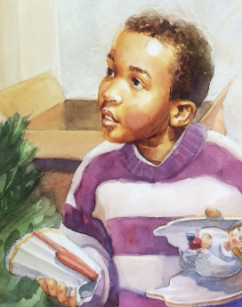
An Angel Just Like Me was written nearly twenty-five years ago, but is still as relevant today. It is the story of African American boy Tyler’s search for an angel that looks like him to put on the family Christmas tree. This makes a great prompt for encouraging children to think about the stereotypes and assumptions they make about the Christmas story and about the wider world they live in. We hope that the ideas in this booklet will inspire you to explore the story and the issues it raises, in a way that is relevant and memorable for the children in your class or school.
This pack contains creative art ideas, Collective Worship resources and RE materials based on the Hampshire Living Difference 111 cycle of enquiry on Angels, with ideas suitable for both KS1 and KS2.
We can also send you detailed Y2 English planning, where the children rewrite the story from Tyler’s point of view.

We hope you enjoy using this book with your children and exploring the issues around whiteness and diversity. It would be great if your children could respond practically, perhaps by making their own multicultural Christmas cards or decorations, or by using their voice to encourage others to manufacture, stock or buy racially diverse Christmas resources. We would love to know how you get on, so please send us any anonymised photos, examples of children’s work or children’s comments that we could share more widely.
Starter activities
You might like to kick-start the project with a hook to stir the children’s imaginations and help them engage with the story. Perhaps you could scatter angel feathers in the classroom or school entrance and get the children to speculate about where they came from? Or create a treasure hunt with an angel, a star, nativity figures and other elements from Tyler’s story? Or perhaps a letter could arrive from Tyler, asking for the children’s help?

An Angel Just Like Me
Collective Worship – Teacher guidance
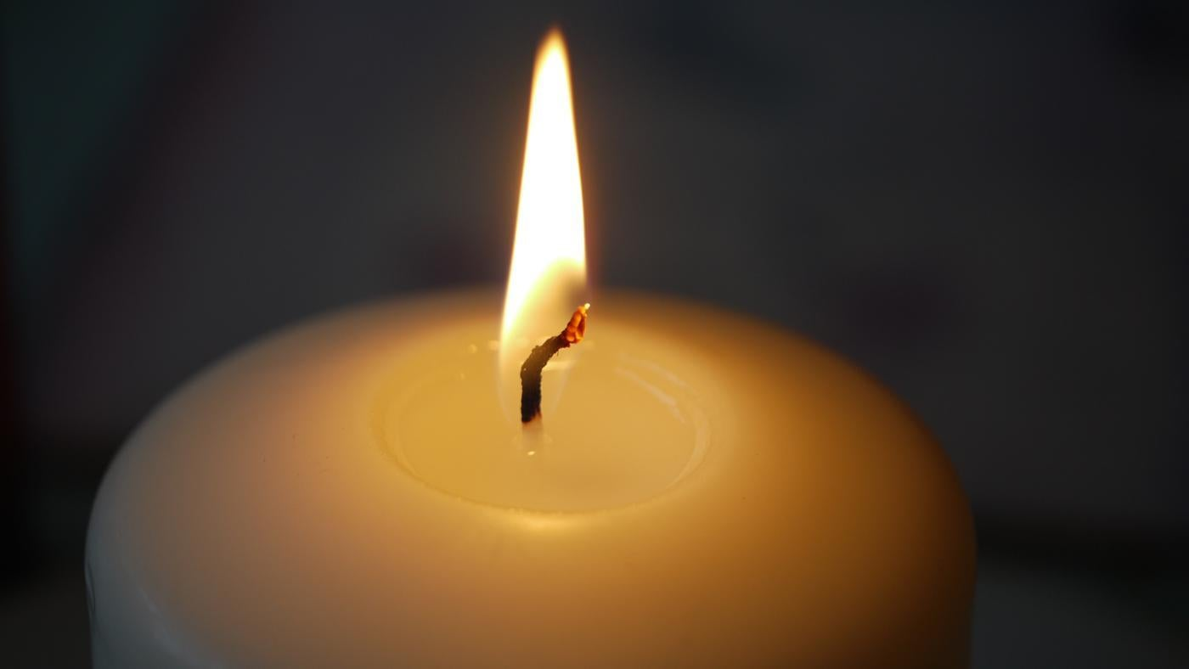

There is a separate PowerPoint presentation to support these notes.
Gathering
Slide 1

Worship begins with music (You could use Abba ‘I have a Dream’ - YouTube link on slide 1 - or Robbie Williams ‘Angels’ or a Christmas carol such as ‘Hark the Herald Angels sing’) as children come to join worship. Welcome the children to worship and remind them of the special time that is beginning. Begin the worship by lighting a candle and following the school’s usual gathering routine.

Engaging

Show the children a feely bag containing Christmas decorations and other items from the story. Ask volunteers to come up and try to work out what is inside the bag.

Slide 2
Explain that they are going to listen to a story that includes some of the items that were in the feely bag. Either read the story yourself, or play the link on slide 2.

When you have finished, ask them to turn to the person next to them and talk about what they think the main message of the story was. Ask a few children to share their ideas.

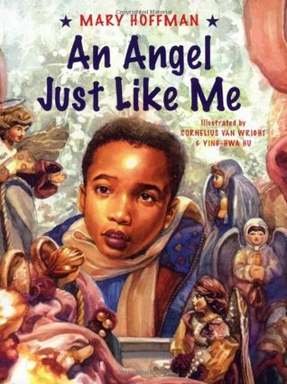
Slide 3
Tyler asks why angels are all pink with golden hair. What do the children think? If angels exist, what colour are they? Can you have black angels like Tyler? Why do they think it’s so hard to find Christmas cards and decorations with black angels on them?

Slide 4
Tyler also wonders about Father Christmas and why they are so often white. Do the children think you can have a Black Father Christmas? Or a Chinese one? Or Indian? The Father Christmas story is based on St Nicholas who came from modern day Turkey, so his skin was probably brown.
What about Jesus? He was a brown Palestinian, but so often he’s shown as white., with fair hair and blue eyes. At least there was one of the Three Wise Men who looked like Tyler’s Dad!

Slide 5
Tyler decides to put a star on the tree, because they are the same for everyone. Was this the right thing to do? Was he right to want an angel just like him? Do you think he felt left out by all the white angels? Why?

Responding
This book was written nearly 25 years ago (1997). Do the children think it’s still relevant today? In what way?

Ask them to shut their eyes and think quietly. How do we treat people who may look different from us? Are our friends all the same as us? Do we ever leave people out of our games or conversations if they’re not the same as us? (You may need to adapt these questions to suit the context of your school)

Slide 6
Explain that you are going to pray a teaspoon prayer. TSP = Thank you, Sorry, Please. Invite the children to say Amen at the end, if they agree with what you have said.

Dear God,
Thank you that you made us all different. Thank you that we look different from each other, that we like different things and we have different personalities.
Sorry that sometimes we leave people out or think that their ideas don’t matter, if they are not the same as us.
Please help us to be friendly to everybody and to enjoy the diverse, multicoloured world that you made.
Amen

Sending
Challenge the children to keep their eyes open for multicultural angels, Father Christmases and nativity scenes.

Ask them when they go back to their classes, to think of something they could do to respond to the story of Tyler and the angel. Perhaps they could design their own Christmas cards or decorations that reflect different races and nationalities? Perhaps there are people they should talk to about the need for more diversity in Christmas cards and other images? Ask them to come back to the next collective worship with some suggestions for what they could do as a result of reading ‘An Angel Just Like Me.’

KS2 Stereotypes / Angels - Support materials for RE
These ideas support the Contextualise and Evaluate steps of the Hampshire Living Difference 111 unit on Imagery (Angels) which looks at angels in the context of stereotypes. The ideas can all be adapted for use with younger children.
Contextualise
These angel images should be looked at alongside the Biblical texts from the Nativity story. Obviously you will need to use a text that is pitched at the right level for your class, such as the Lion Storyteller Bible or the Children of God Storybook Bible for younger children and the Good News Bible or the Message version in KS2. The Bible Gateway is a useful website for looking at different translations of a Bible passage.
The Angel’s visit to Mary (The Annunciation) is in Luke 1: 26 – 38 and the Angels’ visit to the shepherds is in Luke 2:8 – 20. Matthew 1:18 – 25 also has a story of an angel speaking to Joseph in a dream.
After you have looked at the artwork, you could ask the children to find three connections between the painting and the Bible story. Discuss with them whether they think the artists have captured the feel of the story, or whether they would have depicted the angels in a different way.
There are many artists’ impressions of the angels in the Nativity stories, but the selection below offers a good starting point. The ‘Picturing Christianity’ resource (which came free with Understanding Christianity) and ‘Picturing Jesus’ have lots of helpful suggestions for exploring artwork with children. Some of these ideas are included in these notes for you to choose from.

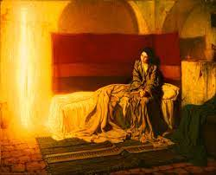
‘The Annunciation,’ Henry Ossawa Tanner
The artist chose to show the angel as a beam of light, rather than giving him an obviously human form. Why do the class think he did this?
You could ask the children for five words to describe the painting and / or three questions they have about it. It might be useful to talk about the difference between open and closed questions and encourage them to think of questions with multiple answers, to open up the discussion.

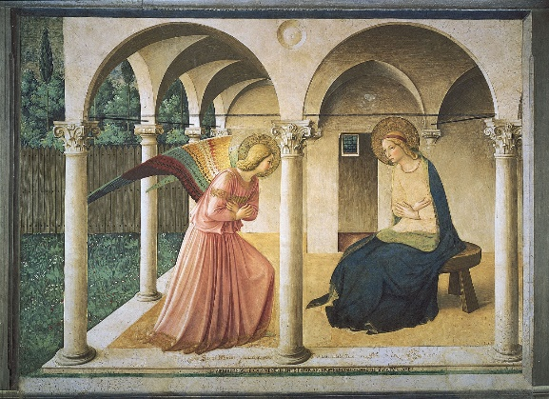
'The Annunciation,' Fra Angelico
This painting was one of the first to show Mary in a more natural setting, rather than seated on a throne. The angel seems to be having a quiet word with her, rather than making a grand announcement.
What do the children like or dislike about the picture? What puzzles them? Can they see any patterns What might Mary see, hear, smell, taste or touch in this scene? What do they think she would think and feel?

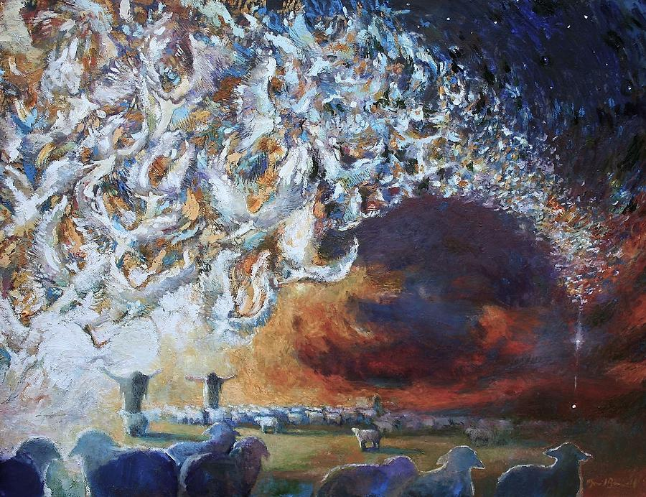
‘Seeing Shepherds,’ Daniel Bonnell.
The artist asks: What colour is made when a host of angels beat their wings? What does a host of angels even begin to look like?
You could give the children a section of the painting and ask them to use their imaginations and Luke’s story to draw the rest. Then compare theirs with the artist’s original version. What is the same? What’s different? Which is truer to the Bible story? Which is better at depicting a multitude of angels?
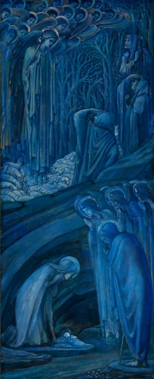
‘The Nativity,’ Edward Burne-Jones.
You could put the children into groups and ask one person at a time from each group to come up and look at the picture for ten seconds, then return to their group and start to draw from memory. Each group member takes a turn to memorise part of the painting and add to their group’s picture. Finally reveal the original painting and start to discuss what they see.
Why do they think the artist has used blue and gold? What does that say about the angels? Which other colours would work well?

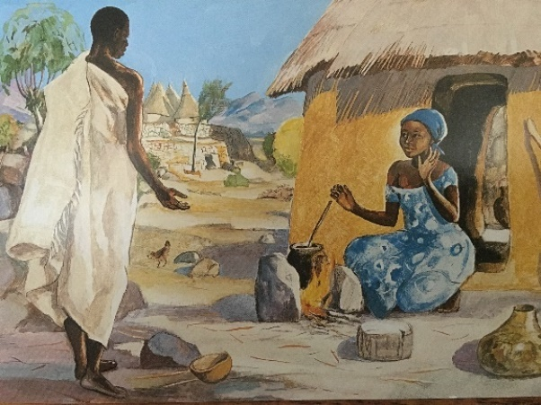
The Annunciation, Jesus Mafa.
This painting introduces children to the idea that the characters in the Nativity story could be Black, or brown, or from different parts of the world. It was created in Cameroon in the 1970s, when a group of missionaries realised that all their resources were unsuitable, because they presented images of Jesus and Christians as white Europeans. What do the class think of painting Mary and the Angel as Black Africans? What if they were Chinese? Or South American? Would it matter? Why / Why not?

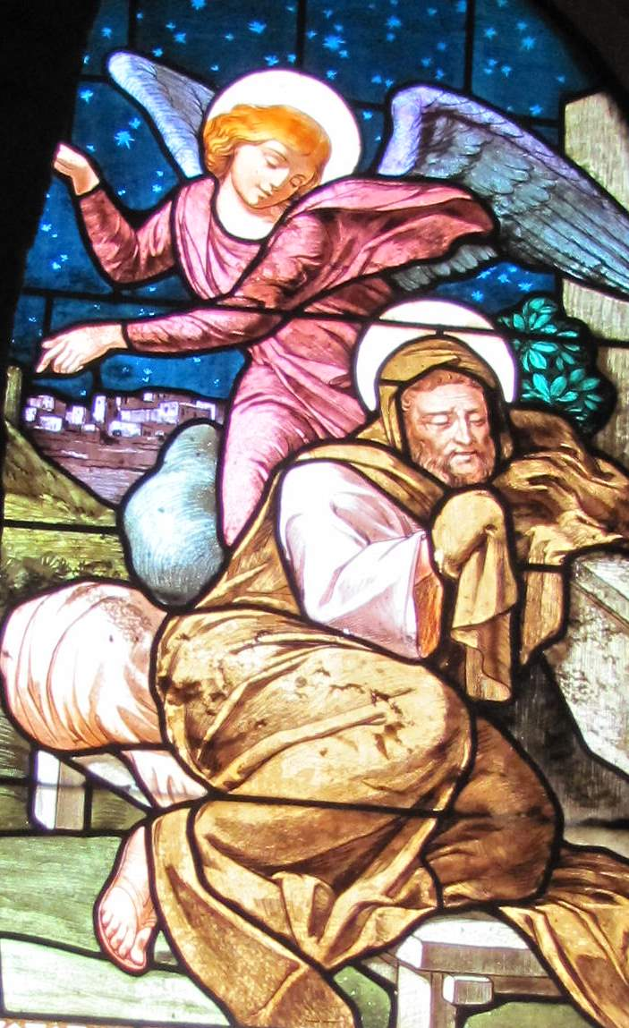
‘The Angel Appears to St Joseph in a Dream.’ Church of St Joseph, Nazareth.
This stained-glass window is from a church in Nazareth that is supposed to be built on the site of Joseph’s carpenter’s workshop and the house that Jesus would have grown up in.
You could give children a piece of paper divided into three, with this picture in the centre (Or ask them to draw a quick sketch of the picture in the centre.)
On the left, ask them to draw what they think was happening ten minutes before (Was Joseph planning to send Mary away? Was he worrying about the future?) and on the right, what happened ten minutes after. (Or an hour before / a day before / a week before.)
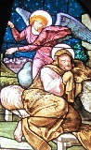

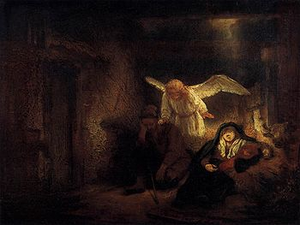
'The Dream of Joseph,' Rembrandt.
This comes from a later part in the story, when Joseph is told to take Mary and Jesus and escape to Egypt because Herod is trying to kill the baby.
You could sit the children back-to-back and ask one of them to describe the picture to their partner, who has to draw what they are told without looking at the painting. At the end they can look at the original and then swap over and repeat the activity with a different picture.

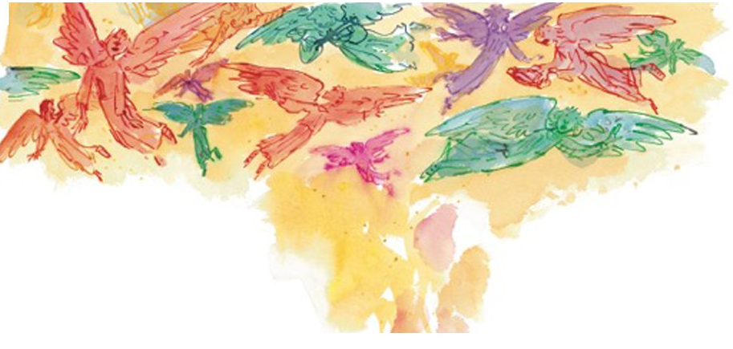
You could also look at Michael Morpurgo’s book ‘On Angel Wings’ and talk about Quentin Blake’s angel figures. Do his pictures add anything to our image of what an angel is like?

Other ideas for using angel artwork
- A silent debate Choose a selection of pictures and put each one in the centre of a large piece of paper. Ask children to walk round the room and write their ideas and questions on the backing paper. (Or keep the children sitting in groups and move the pictures round every few minutes.) They read what has been written before and add their own thoughts and comments, agreeing or disagreeing with what’s already been said.
You can structure this, by asking everyone to ask a ‘Why’ question, then an ‘I wonder’ question, then asking them to imagine that they are in the picture etc

- Class art gallery Ask the children to work in pairs and choose an angel painting linked to the Nativity story. They need to imagine that they are writing a catalogue entry for an art exhibition; they can write about the colours and form and the feelings and emotions of their chosen picture. They also need to explain how it is connected to the Nativity story and what they think the artist might be trying to say. How has the artist used their imagination? What questions would they want to ask the artist about their work? You could put the pictures and the children’s comments on display and maybe ask another class to view their work.
Evaluate
Introduce Mary Hoffman’s book, An Angel Just Like Me. Although the book is currently out of print, second-hand versions are available from the usual on-line retailers, or you could download an e-book.
Why isn’t Tyler happy with the images of angels he finds in the shops? Is he right to want an angel that looks like him? Is there any reason why angels should be pink and have gold hair? In the past, some people may have thought this made them more beautiful, or more pure or holy – do we still think like that today?

Ask the children to do their own research; can they find images of Black or multicultural angels? Look at pictures on Christmas cards, or search for Black angel figures online. (Maybe start with a general search for angels, before specifying Black angels.)
What have we learned about angels? Have our ideas changed? Do we think it’s important to have different images of angels? It might be important for a black boy like Tyler in the story, is it important for other children?
Return to the earlier discussion on stereotypes (Step 2, Apply). Is it a stereotype to think of angels having fair hair and blue eyes?
What could we do? Perhaps the children could design their own Christmas cards or decorations with angels (or other Nativity characters or Father Christmas figures) with different racial characteristics. Could they share their ideas with the rest of the school in collective worship? Or involve parents and the wider community? Could they write to local shops or greetings card manufacturers asking them to stock a more diverse range of cards? This is a good opportunity to encourage children to find their voice and make themselves heard!
The word ‘angel’ comes from the Latin angelus, meaning messenger. What messages did the angels bring in the Nativity stories?
If God sent an angel or messenger to the world today, what do you think their message would be? A message of hope and encouragement? A warning about things that need changing in the world?
You could use an activity such as a goldfish bowl discussion to debate this. Put the children in two concentric circles, facing each other. Give them a minute to share their ideas with the person opposite them, and a minute to listen to their partner, then ask everyone to move one place to the left and discuss their ideas with their new partner. Keep moving the children round for as long as it is worthwhile, then open up a class discussion or ask the children to write down their thoughts.

KS1 / 2 Angels – RE Support Materials
These ideas support the Hampshire Living Difference Angels teaching pack which is available from the Hampshire RE Centre.

Communicate and Apply: What do we think angels are? You could show the children a selection of images of angels, including some of the ones in this booklet, and ask them to rank them – which are most like their ideas of what an angel looks like? Why?
If they draw or paint their own angel pictures, then it would be good to return to these at the end of the cycle of enquiry, to see if their ideas have changed at all.

Enquire: Continue to explore different images of angels. Some of the activities in the Stereotypes Unit would be useful for helping the children engage with the artwork. What’s the same / what’s different about the different images?

Contextualise: Read the Christmas story using a child-friendly retelling of the Bible, such as The Lion Story Teller Bible or The Children of God Storybook Bible. (This is a lovely multicultural version by Desmond Tutu). What do they notice about the angels in the story? What do they do / say? What difference do they make to the story?
Use dance or drama or freeze frames or hot-seating, or add music and sound effects to the story, to help the children engage with it in a creative way. Remind them that they are focussing on the role of the angels in the story; are they an important part of the story? Would it matter if there weren’t any angels?
Every year the Bible Society produce a Christmas video. The Well Good News of Christmas or The Christmas Poem might be suitable for your class. You might need to explain that the films were made for Christians and make some assumptions about what people believe.
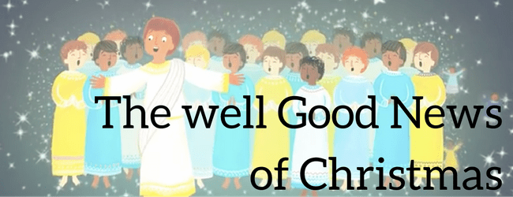

There is a rather quirky animation The Adventures of Mary and Joseph – The Road Movie which has nine short episodes on You Tube. Or for Y6 you might like to use The Modern Day Nativity by a group of Black teenagers, but it’s recommended that you watch it first to check that it is suitable for your class. If you decide to use it, you could discuss its strengths and weaknesses and how the class might improve on it.

Evaluate: At this point you could introduce An Angel Just Like Me. The book is currently out of print, but second-hand copies are available online and you can also download electronic versions.
Why do people often have angels on their Christmas trees? Why does Tyler want a black angel? Does it matter if he has an angel like him or not? Why do the children think it’s important for him?
Was there anything in the Christmas stories we explored that says angels have to have blond hair and blue eyes? Could a Black / Chinese / South American angel still have been God’s messenger in the Christmas story? Would the message have changed in any way?
A lot of angel pictures are based on European art from the Middle Ages or Renaissance, when most of the people living in Europe were white. The artists probably painted angels that looked like them. In the same way, most paintings of the time showed Jesus as a white European, whereas now we know that he was a brown Palestinian. Some people in the past thought that white angels were more beautiful, or more holy; do we still think like that today?
At one point in the story, Tyler decides to have a star instead, because they’re the same for everyone. Is this a good compromise, or should he have kept looking for an angel that looked like him? Challenge the children to look for angels of different races and nationalities on Christmas cards or online. Tyler’s book was written nearly 25 years ago; is finding black angels still a problem today?
Practical outcomes (It would be great if the children could come up with their own suggestions here, to give them ownership of the project.)
What could the children do, now that they have been thinking about angels and have read the story of Tyler’s black angel?
- Could they create their own Christmas cards and decorations showing racially diverse angels (or nativity figures)? Perhaps these could be included in the school Christmas bazaar, or be sent out as the school’s official Christmas card?
- Is there anyone they should talk to or write to about this issue? E.g. could they do a presentation in Collective Worship, or to their parents? Could they put something online or write to local shops or card manufacturers?

- Does this problem go wider than Christmas cards and decorations? Is there anything they could do to make their class or school more inclusive and welcoming?

Understanding Christianity
Not all of you use Living Difference 111 as your agreed syllabus, so you may also like to adapt some of the ideas in Understanding Christianity.
The Digging Deeper Incarnation unit in KS1 suggests using Botticelli’s Mystic Nativity to explore the different characters in the Nativity story and how they recognised that Jesus was God Incarnate. (Making sense of the text.) You could use this as an opportunity to explore other examples of artwork, including some from this booklet, to see how different artists have interpreted the nativity scene.
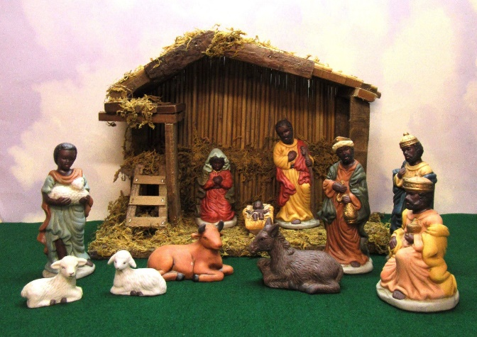
The resource also suggests looking at crib scenes from around the world (Understanding the impact.) This could lead into an interesting discussion about Christianity being a global religion, for example, there are more Christians in India that the UK, and many more in Africa than in Europe. Why is it that many people still think of the angels, Mary, Joseph and Jesus as white, European figures? Discuss whether Tyler’s search for an angel like him is still an issue today.

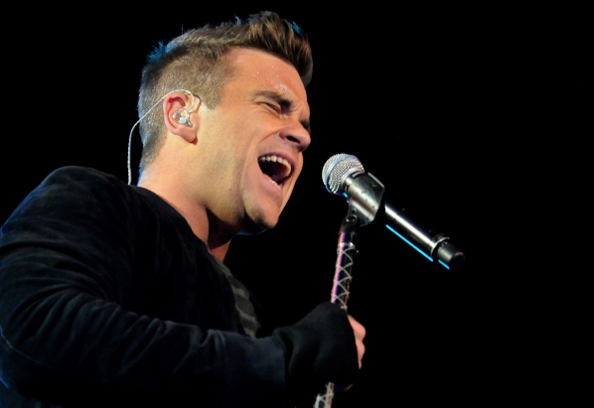
Karaoke Comprehension
This activity inspires children to think carefully about the lyrics to the song Angels by Robbie Williams. There is a good version of the song set to beautiful images and with the lyrics on the link below. Play this first, then study the lyrics in more details using the questions below. These are suitable for upper KS2 children.

https://youtu.be/mhXCnWViVgA?t=13

Teachers are advised to copy and paste the lyrics (below) on to a PowerPoint slide or paper for each child, so children can all see the words as the questions are asked.

I sit and wait. Does an angel contemplate my fate?
And do they know the places where we go when we're grey and old
'Cause I have been told that salvation lets their wings unfold
So when I'm lying in my bed thoughts running through my head
And I feel that love is dead, I'm loving angels instead

And through it all she offers me protection, a lot of love and affection
Whether I'm right or wrong
And down the waterfall , wherever it may take me
I know that life won't break me when I come to call, she won't forsake me
I'm loving angels instead

When I'm feeling weak and my pain walks down a one way street
I look above and I know I'll always be blessed with love
And as the feeling grows, she brings flesh to my bones and when love is dead
I'm loving angels instead

And through it all she offers me protection
A lot of love and affection, whether I'm right or wrong
And down the waterfall, wherever it may take me
I know that life won't break me when I come to call, she won't forsake me
I'm loving angels instead

And through it all she offers me protection
A lot of love and affection, whether I'm right or wrong
And down the waterfall, wherever it may take me
I know that life won't break me when I come to call, she won't forsake me
I'm loving angels instead.
Questions to ask:

- Where do you imagine the singer might be when he is sitting and what might he be waiting for?
- Could the angels he sings about symbolise different things for different people?
- What does the question ‘Does an angel contemplate my fate?’ mean?
- What does salvation mean in the Bible? Why might the singer need protection?
- What do you think he means by salvation letting angels’ wings unfold?
- What does the phrase ‘a lot of love and affection whether I'm right or wrong’ mean? Do you think that angels exist? Do they love us even if we have done wrong?
- How do you think the singer was feeling before he wrote this song? Was he happy or sad? What line in the song tells you this?
- Why do you think the phrase ‘I’m loving angels instead’ is repeated so many times?
- What does the ‘waterfall’ represent?
- Why do you think his pain walks down a ‘one way street’?
- Why does he look above? Are angels always ‘above’ or could they be anywhere?
- Why are angels so important to the singer? Are they important to you?

Art Ideas
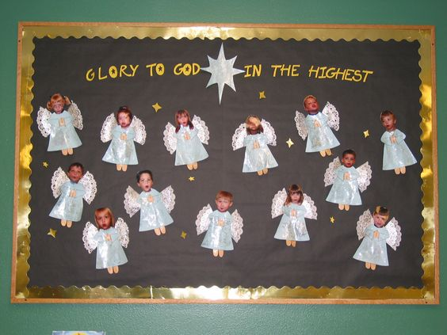

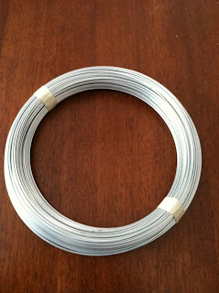
Wire Angels

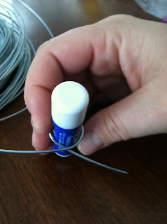
You will need:
16 or 18 gauge wire
Wire cutters
Pliers
A tube of lip balm or similar size tube.
Making the angels directly off the spool means that you do not need to worry about the length of wire. Alternatively, make one in this way as a prototype and then unfold to measure the length of wire used.

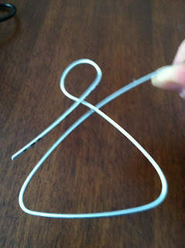
Start by wrapping the wire around the tube of lip balm. Leave yourself about a 5cm tail at the end of the wire.

Where the wires cross is going to be the neck of the angel. Now using three fingers as your measuring device shape the skirt. Each side and bottom of the skirt will all be approximately three fingers long.

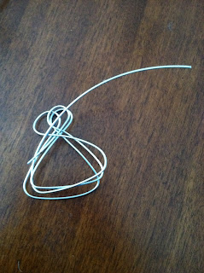
Continue to work the wire in a figure of 8 pattern. When you reach the neck again use the lip balm tube to wrap another head for the angel and then repeat making yourself another skirt, repeat again. When you are finished you should have three heads and three skirts ending at the neck. Leave yourself approximately a 10 cm tail and cut the wire.

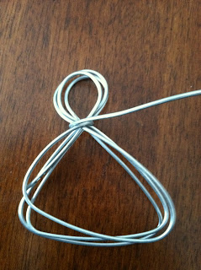
Now using the tail that you just cut wrap the neck of the angel until you have no more wire. Use the pliers to help tuck in the end.

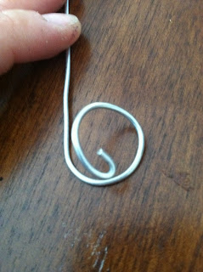

Making the wings starting with the halo.
Taking the end from the spool again wrap the wire around the lip balm tube, do not leave a long tail. Using the pliers bend the end of the wire around so it makes sort of a curly cue in the middle of the halo.

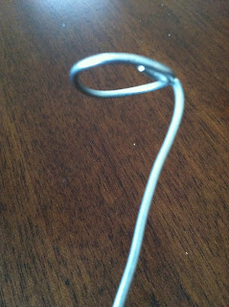
Now bend the long end of the wire straight down to make the stem of the halo. This should be at a 90 degree to the halo. Leave a long enough stem so that it will go past the head and to the location of the neck. This is about 5cm.

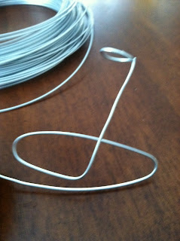

To make the wings use 2 fingers to wrap the wire around on each side of the halo stem. Make a loop for the wings making sure that there are three wings on each side of the body.

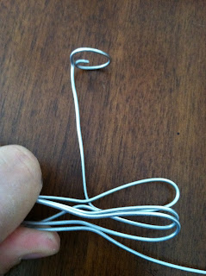
Pinch the wings together in the middle. To do this, bend each wire individually in the centre, so that they will come together at the neck. Cut a 3” tail at the end of the wings. Now wrap the tail around the centre of the wings to the end of wire. Use the pliers to tuck in the ends and avoid future injury.

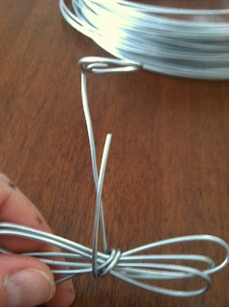
Using the short end on the body, attach the wings to the body by wrapping the wire around the center of the wings.

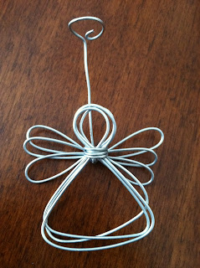

Now we have a completed angel. You can tie ribbon around the neck if you want to. There are a variety of things that you can do with your angel. You can use it as a photograph holder, Christmas ornament, or wall hanging.

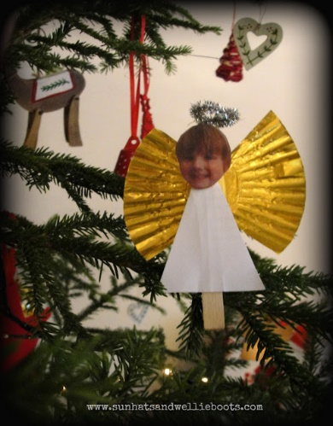
Personalised Peg Angels for younger children

These little angels look great pegged onto a tree, but are also perfect to add to any small world play setups, or Nativity scenes. This is also a good way of encouraging storytelling, either telling the story of ‘An Angel Just Like Me’ or placing a child at the heart of a story.

You will need:
Clothes pegs, old Christmas or birthday cards, cupcake cases and photographs. You may choose to use photos of the children, but you could cut out faces from magazines of people from a variety of cultures to show that angels do not all look the same.
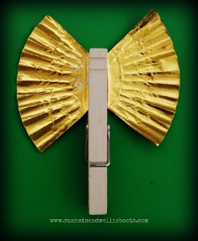
Flatten the cupcake case and cut it into quarters.

Glue two of the sections onto the back of the peg.

Cut a triangular shape from an old Christmas or birthday card and stick it to the front of the peg. Chose a photo and stick it to the top of the triangle. For a finishing touch, add a pipe cleaner halo.

Easy Clay Angels

You will need:
Air Dry Clay
Circle and heart cookie cutters
Rolling pin
Parchment paper
Crochet Doily
Stamp to create texture (optional)
Clay knife
Acrylic Paint/brush - white
Glitter
Wire for hanging

Start by rolling a small amount of clay into a ball and then smoothing it out thin using a rolling pin.
Cut out a circle using the cookie cutter and then do the same with the heart cookie cutter.

To create a texture in the clay, lay the crochet doily on top of the clay circle and heart and press the rolling pin over them.

Children can personalize the angels by using different kinds of stamps.

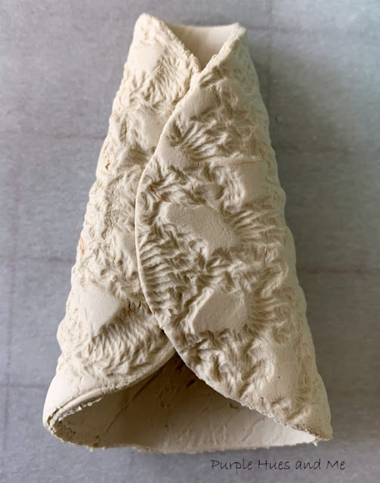
Fold over the circle sides, overlapping into a triangular shape that's narrow at the top and flares out at the bottom, for the body.

Make wings with the heart by using the clay knife to slice three quarters of the way through the middle of the heart at the bottom. Be sure to leave the upper portion intact.

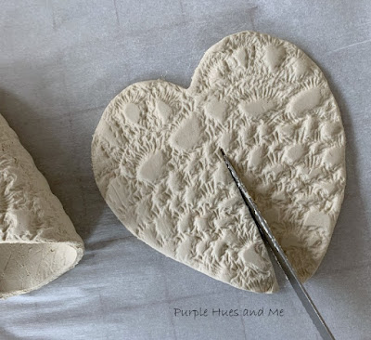

Then spread the heart open, leaving the uncut areas together for a set of wings!

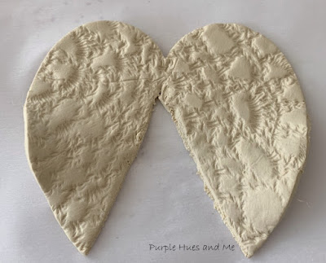
Place the angel body on top of the wings and use a finger to pinch down to seal together. You can use a skewer stick to make a small hole in the back for a hanger.

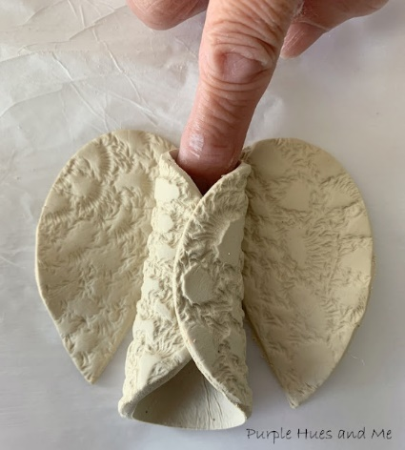
Then with a small amount of clay, roll into a ball for the head and gently place it between the opening at the top. Press the clay of the head, body and wings together to seal at the top.

Make a halo by rolling a tiny piece of clay back and forth in the palm of your hand for a small coil and then shape into a ring. Attach to back of head, pinching together. Use a bit of water to seal, if needed. Let the clay angel air dry for at least 24 hours.

Paint the angels white and sprinkle with glitter while the paint is still wet. You may choose to paint the faces different skin tones to reflect the message of An Angel Just Like Me.

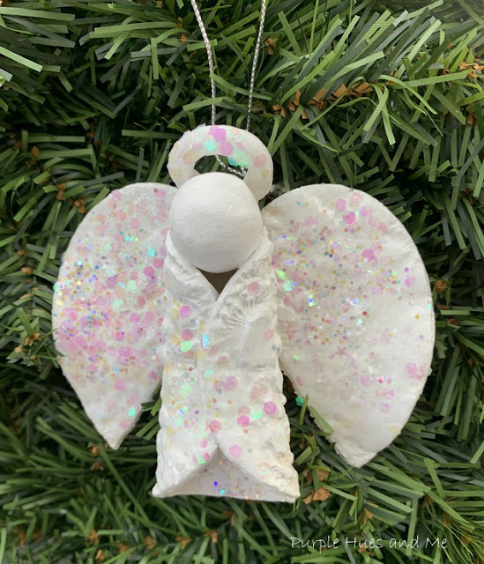

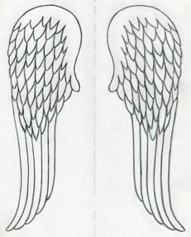
Advanced sketching of angel wings
This is an activity offering greater challenge for young artists.
You will need:
Good quality A4 paper and sharpened sketching pencils, a rubber with sharp corners.
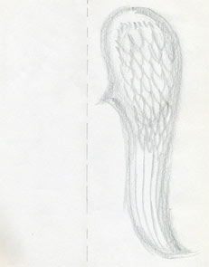
Fold the paper half and make a weak pencil line on the folded vertical line. This line is the middle line between the right and left wing. It will ease the drawing process.
Allow children to see an enlarged copy of the drawing above and decide the total shape and size of one of the wings – right or left – it depends which one they decide to start with.
Ask the children to draw the outline of one wing using light strokes until they are happy to draw over the soft line using a darker pencil.
Encourage the children to notice how the wings are divided into 2 sections. The upper part is shaped like a tear where the most of short feathers are concentrated.
On some spare paper let the children practise tilting the pencil and drawing by using one side of the graphite to achieve the wider touch on the paper.

Using this method, ask the children to sketch the spiky ends of feathers on the top part of the wings. They look as if they are piled on each other and, in fact they are. Leave the lower area blank.
Add the long feather lines into the prolonged lower area. Keep everything just approximate at this stage. The feathers are refined gradually throughout this process.

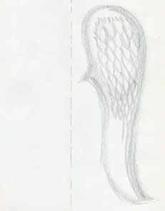
Using the rubber, start to erase the excess outer silhouette lines as necessary. This step will give children a clearer shape of the angel wings.
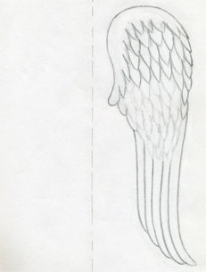

Continue erasing the excess pencil lines and blurs on the entire drawing. Outline the final shape – ending of the long wings that are harmoniously streaming into each other.
Make additional corrections by pencil where the lines were erased so that you have exact and sharp looking outlines.
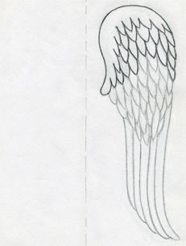
Now use a softer 2B pencil, because children need to really darken the outlines on every single feather on their angel wing drawing.
This is necessary because they need to use the vertical line that they have created in the first step of this sequence to fold the paper and imprint the wing on the opposite side of the paper. opposite side of the paper.
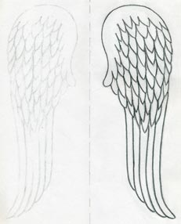

When children have highlighted the outlines on all feathers with a 2B soft pencil, ask them to fold the paper in half and gently push the face of the drawing to the opposite side of the paper.
The imprint should look like this.
Make sure the paper will not move while imprinting. This simple technique will ensure that children do not need to draw angel wings on both sides separately and will get an exact mirror imprint effortlessly.
Draw stronger pencil lines over the imprinted lines so the wings match in intensity.
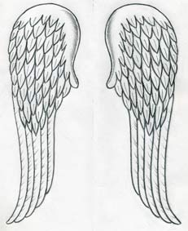
The very last step is to mark out the middle part of the feathers and to make short strokes on long feathers here and there. Finally children can put a slight shade on the upper curved part of the angel wings for further definition.

Further angel ideas in pictures:

Rocher angel on a stick

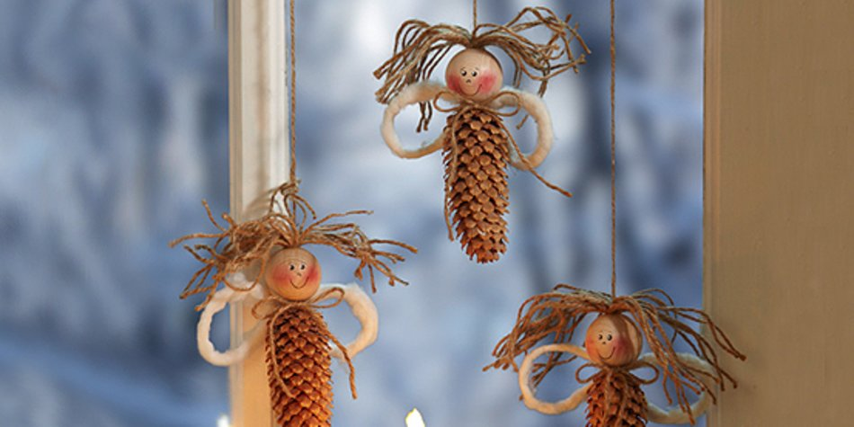
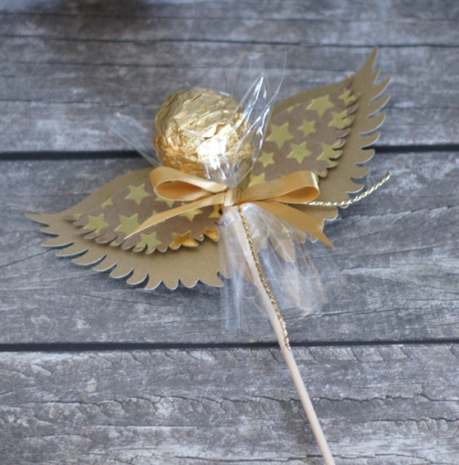
Pinecone angels
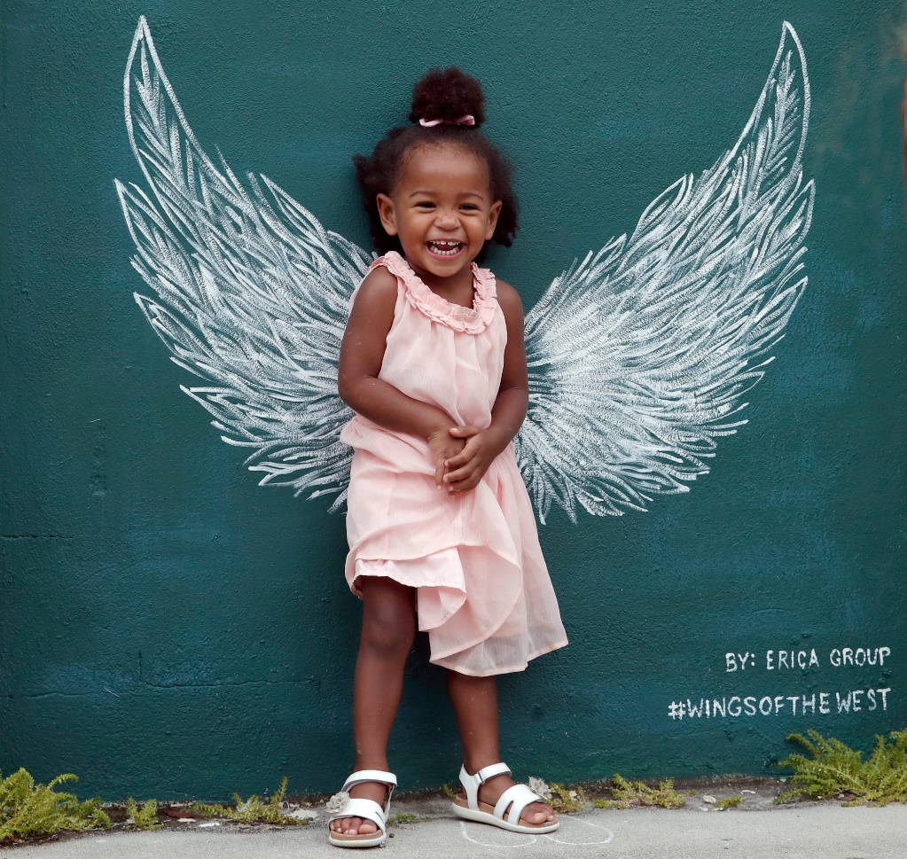
Giant angel murals

In the artwork below the back of each feather could be used for prayer writing.
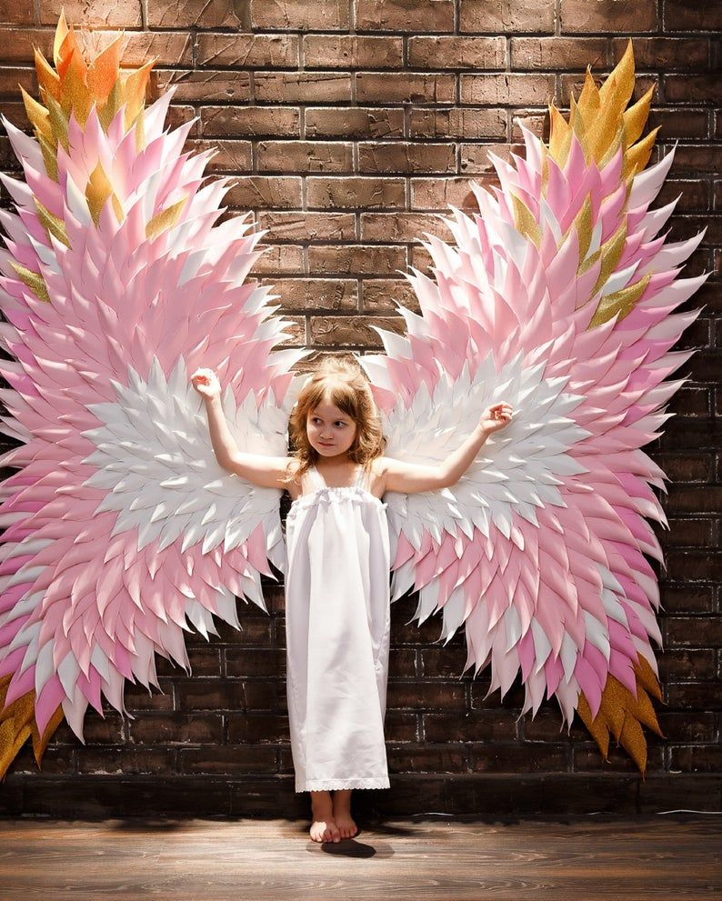
The Angel of the North
If you wanted to explore a competely different kind of angel, ask your class to research the Angel of the North, possibly the world’s largest angel sculpture and one of the top ten landmarks in the UK. There is a downloadable School Resource Pack here. Anthony Gormley built his angel on the site of an old colliery, to show that in a place where men had worked underground in the dark for hundreds of years, there could now be light and hope.
You could challenge the children to design their own Angel of (Something) – maybe using the name of your school, or a value or activity that means something to them. (Angel of Hope? Angel of Dance?)
Perhaps they could use junk modelling to create their own version of Antony Gormley’s angel.
Does an angel have to look like the traditional pictures, or can it be made of steel and the size of a jumbo jet? What do they think the artist was trying to say, by designing an angel like this? What is their design trying to communicate?

If you are interested in thinking through some of the issues raised by ‘An Angel Just Like Me’, there are some interesting articles online which you could read. This is an article from The Independent which was written in 1997, when Mary Hoffman’s book was first published, which talks about the fact that Christmas images are almost all white and Western and whether this makes some children feel excluded. This is a blog from 2013 which deals with the problems of finding racially diverse dolls and the claims by Megyn Kelly on Fox News that Father Christmas and Jesus were both white.

If you have more time, then ‘God is not a White Man’ by Chine McDonald is challenging and very readable. She writes about her experiences of growing up as a Black Nigerian in 1980s Britain, such as when she started school and realised for the first time that she looked different from the other children!

