#10 pMAP19 Final Proforma
Please use the following proforma to outline your pMAP plans. It helps us to process them if they are all in the same format.
If you have any questions, please let us know – thanks!

Guidelines
Summary Plan
This gives us an overview of what you are planning to do and why. The columns are as follows:
- Objective #: You will need to articulate what objectives you have agreed as a parish.
If you have too many you will simply not be able to achieve them all in the timescale.
We suggest up to 3 for a parish.
If you create a benefice MAP you might have 2 that you share across the parishes, and then 2 specific to the individual parishes.
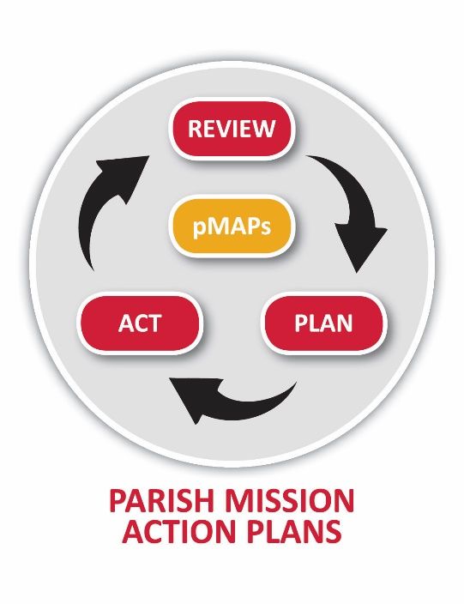
- Objective Description: Explain here what it is you want to achieve.
- Impact: What difference will this make in the Kingdom of God?
- Strategic Priorities engaged with: Which of the 4 SPs does this objective engage with? (See key in appendix 1)
- aMAP Projects: Which of the 12 aMAP projects does this objective engage with? (See key in appendix 1).
Please note: it may not impact any of them!

Detailed Plan
We have included two worked examples to hopefully make things clearer.
- Objective #: As above
- Evidence: What signs of growth will you see if this happens?
- Steps: What steps will you take to make this happen?

pMAP19 - Summary Plan
Your Objective # | Objective Description: What do want to achieve? | Impact: How will this make a difference to your parish? We look for this to happen under God. | Strategic Priorities Engaged with | aMAP Objectives Engaged with
1
2
3

Detailed Plan
For each of the objectives in your summary plan, please show below how you plan to deliver them.
This is the working document you will need to keep referring to, and keep on your PCC agenda.
Your Objective # | Evidence: What do you want to see happening as a result of delivering your objective? How will you know you have been successful? What can you count or measure? | Steps: What steps will you take to achieve this? What will you input to make it happen? Who does what by when? How will it be achieved?  What resources will you need to make it happen?
1
2
3

Appendix 1: Key

Diocesan Strategic Priorities
See http://www.winchester.anglican.org/about-us/strategic-priorities/
SP1 – we grow authentic disciples
SP2 – we re-imagine the church
SP3 – we are agents of social transformation
SP4 – we belong together in Christ

Mission Action Objectives (aMAP)
Four Major Step Change Projects | Three Smaller Projects | Five Projects in progress
AM1 – Rural Benefice of the Future | AM5 – Thy Kingdom Come | AM8 – Rule of Life
AM2 – Major Development Areas | AM6 – Social Transformation | AM9 – Companion Links
AM3 – FE/HE | AM7 – Vocations | AM10 – Schools
AM4 – Resource Churches |  | AM11 – FxC
 |  | AM12 – Alpha/Pilgrim

