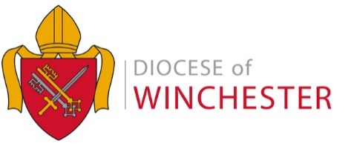

DIRECT DEBIT PAYMENTS SCHEDULE – 2018

Parish:………………………………… Deanery: …………………………………

Please confirm by which option we should collect your 2018 Common Mission Fund (CMF) contribution

  - 10 equal payments

  - 12 equal payments

  - Payments as outlined in the schedule below

DATE | £
January 24th
February 23rd
March 23rd
April 24th
May 24th
June 22nd
July 24th
August 24th
September 24th
October 24th
November 23rd
December 24th

Total

Name: ………………………..………………
(Block Capitals)

Treasurer’s Signature: ……………………………

Date: ………………………………

