Diocese of Winchester
Lent Lectures
21 March 2017
LECTURE TWO
Church Growth: How it can Happen
David Goodhew
Cranmer Hall, St Johns College, Durham

Data Quality
- M. Wigglesworth, ‘A Critical Evaluation and Theological Reflection on ‘Worshipping Community’, As Used By the Church of England Statistics For Mission Form (2012 and 2013), As a Measure of Church Size and Its Implications For Mission With Particular Reference to the Diocese of Sheffield’, MA Dissertation, September 2014 – accessible at: http://community.dur.ac.uk/churchgrowth.research/research-outputs/conference-papers-dissertations

Some Empirical Data on Church Growth in Britain

London
Number of churches (of all denominations) in Greater London
- 1979 3350
- 1989 3559
- 1998 3862
- 2005 4087
- 2012 4791

Sunday Church Attendance (of all denominations) in Greater London

1979 696 000
1989 650 000
1998 618 000
2005 623 000
2012 722 000
- Other, more detailed, studies of London churches indicate that these figures are probably an undercount.
- Such expansion is happening mainly outside the historic denominations, but some is happening within the historic denominations. Parts of the CofE and RC’ism and much of the Baptist denomination are growing or stable.
Anglican Diocese of London
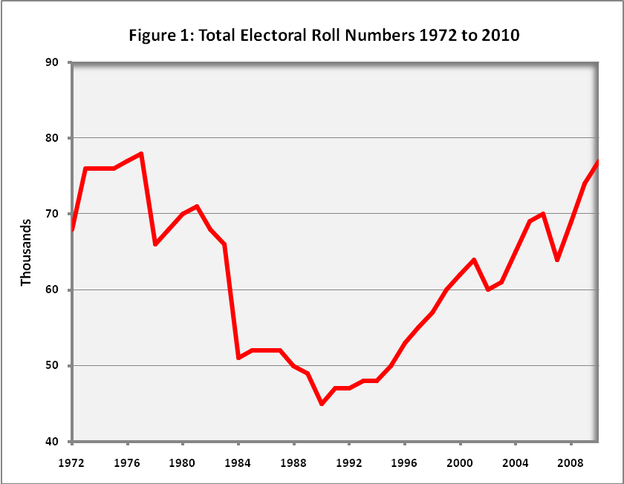

Beyond London:
- There is significant church growth happening in much of the area within 70 miles of London and further afield in towns such as Birmingham, Edinburgh and Newcastle.
- Recent research on the North East indicates that 125 new congregations were founded in the region since 1980. These new churches have a combined Sunday attendance of c. 12 000 and baptised around 1000 people in the last 12 months. Of the 125 congregations, about two thirds contained a significant % of people from minority ethnic communities. Multiracial churchgoing is growing rapidly, even in regions previously seen as ‘white’.

Wider Societal Shifts: Comparison of Pubs and Churches

- Number of pubs in Britain in 2003 was 66 690, but in June 2016 it was 52,201
- Number of churches in Britain in 2000 was 48 499. In 2013 it was 50 660.

British ‘Non-Mainline’ Churches
2000 2005 2010
Orthodox 278 154 314 667 333 630
Pentecostal 223 464 286 929 354 934
‘New’ 170 259 189 873 223 290
The combined membership of Pentecostal churches, Orthodox churches and new denominations founded within the last 50 years, was around 100 000 in 1960 but was over one million people in 2012.

Cathedrals and Growth
2001 2010
Sunday congregations: 15,500 15,800
Weekday congregations: 4,900 11,600

Seven Key Factors in Growth:
- Concrete Expressions of Intentionality
- Focus on the under-25s
- Use the Trade Routes
- Starting New Churches
- Give People Ways In
- Shut the Back Door
- Resources

When does faith come ?
84% of people become Christians by the age of 25
72% of whom had done so by the age of 19

Cutting Clergy Numbers

P. Brierley, Capital Growth What the 2012 London Church Census shows (ADBC 2013), p.23.
Brierley, Capital Growth, p.57.
Being Built Together: a Story of New Black Majority Churches in the London Borough of Southwark, (University of Roehampton, 2013).
J. Wolffe and B. Jackson, ‘Anglican Resurgence: the Church of England in London’, in D. Goodhew, Church Growth in Britain, 1980 to the Present, (Ashgate 2012), p. 32; Brierley, Capital Growth, 57;
Brierley, UK Church Statistics 2: 2010-20; D. Voas, ‘Church of England Growth and Decline since 1980’, in D. Goodhew, Growth and Decline in the Anglican Communion, 1980 to the Present Day, (Ashgate 2016), p.15; chapters by C. Marsh and K. Roxburgh in Goodhew (ed.) Church Growth in Britain, and New Churches in the North East, (Durham: CCGR, 2015), see: http://community.dur.ac.uk/churchgrowth.research/research/new-churches-in-the-north-east
R. Barawrd -Symmons and D. Goodhew, New Churches in the North East (Durham: CCGR, 2015).
P. Brierley, Religious Trends 7, UK Church Statistics, 2005-2015 and UK Church Statistics 2; Guardian 10 Aug 2016, accessed 060317
Pentecostal membership membership was 433 000 in 2012. New churches had an attendance figure of 210 000 in the UK in 2012 – with a membership which is probably higher. Orthodox churches had an estimated 444 000 membership in UK in 2012. See: Brierley, UK Church Statistics 2: 2010-20.
From J. Holmes and B. Kautzer, Cathedrals and Greater Churches, p.10 (Strand 3a of the Church Growth Research Programme, accessible at: http://community.dur.ac.uk/churchgrowth.research/research-outputs/previous-projects/church-growth-research-programme)
Source: Confidently Sharing the Gospel (London 2012)
Data from Strand 3c report, Church Growth Research Programme, p. 88; B. Jackson, What Makes Churches Grow, 97; F. Tweedie, ‘Going Deeper’ report - https://www.churchtimes.co.uk/articles/2016/5-august/news/uk/church-growth-is-linked-to-more-clergy - as reported in the Church Times 050816.

