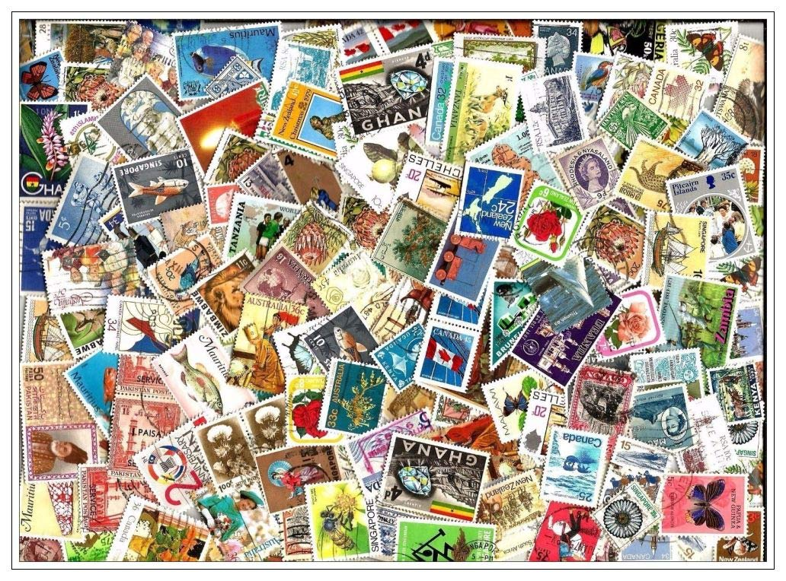
This is a photograph of many different postage stamps from around the world.
How many different countries can you identify? Can you find these places on a world map? If you bought a stamp in those countries, what currency (money) would you have to use?
Standing Together
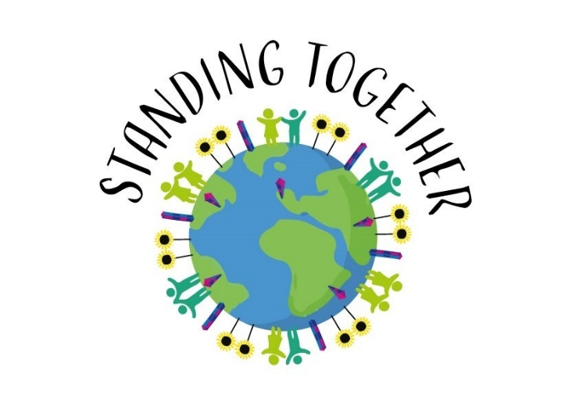
Our project theme this year has been about challenging prejudice (disliking and judging others simply for being who they are) and celebrating difference. These stamps, from many different countries, help to remind us how many different languages, cultures and communities there are in our world. Jesus teaches us to love our neighbour – that includes everyone, no matter their nationality, gender, belief or behaviour. This can be a real challenge but one that is so important if we are to live in peace and happiness with each other. You can start by caring for those in your family and neighbourhood during this time of working from home!

Challenge Time
Stamps are used to show that someone has paid the correct charge for sending a letter or parcel. They often commemorate (or remember) important people, events or follow themes such as animals and plants. Other stamps show the political leaders or Heads of State. For example, Great British stamps always show the Queen’s head.
- Design your own set of stamps to commemorate something special or of interest to you
- Write a letter to someone in another country sharing your best wishes, worries and hopes for the future or maybe to someone in hospital recovering from illness or to a doctor or nurse working hard to help those who are sick. Think about including a simple prayer as part of your letter.

