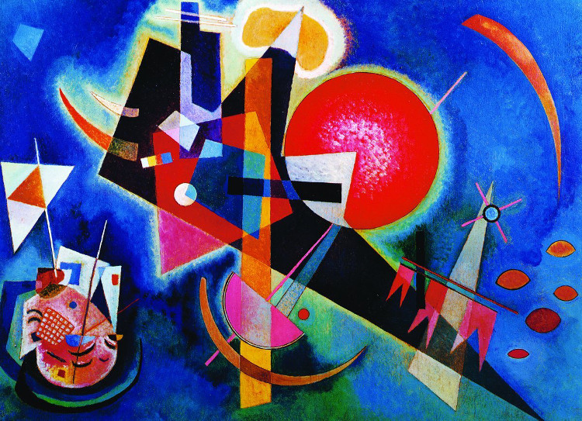
Perfect picture!
This is a painting by Wassily Kandinsky, a Russian artist, 1866 – 1944. It is called ‘In Blue’ and is an example of abstract art.
Question Time!
How many different shapes can you find?
Shapes are often used to symbolise different meanings – Christianity and other faiths use shapes a lot. What can you find out about the symbolism of circles and triangles for example? How about some of the other shapes?
Challenge Time
Kandinsky once said that, ‘Each colour lives by its mysterious life.’ Write a piece of descriptive writing to describe the character of different colours as if they were real people.
Create your own art inspired by shapes and colour. Research other paintings by Kandinsky for inspiration. You can do that by using the following website:
https://www.wassilykandinsky.net/painting1896-1944.php

