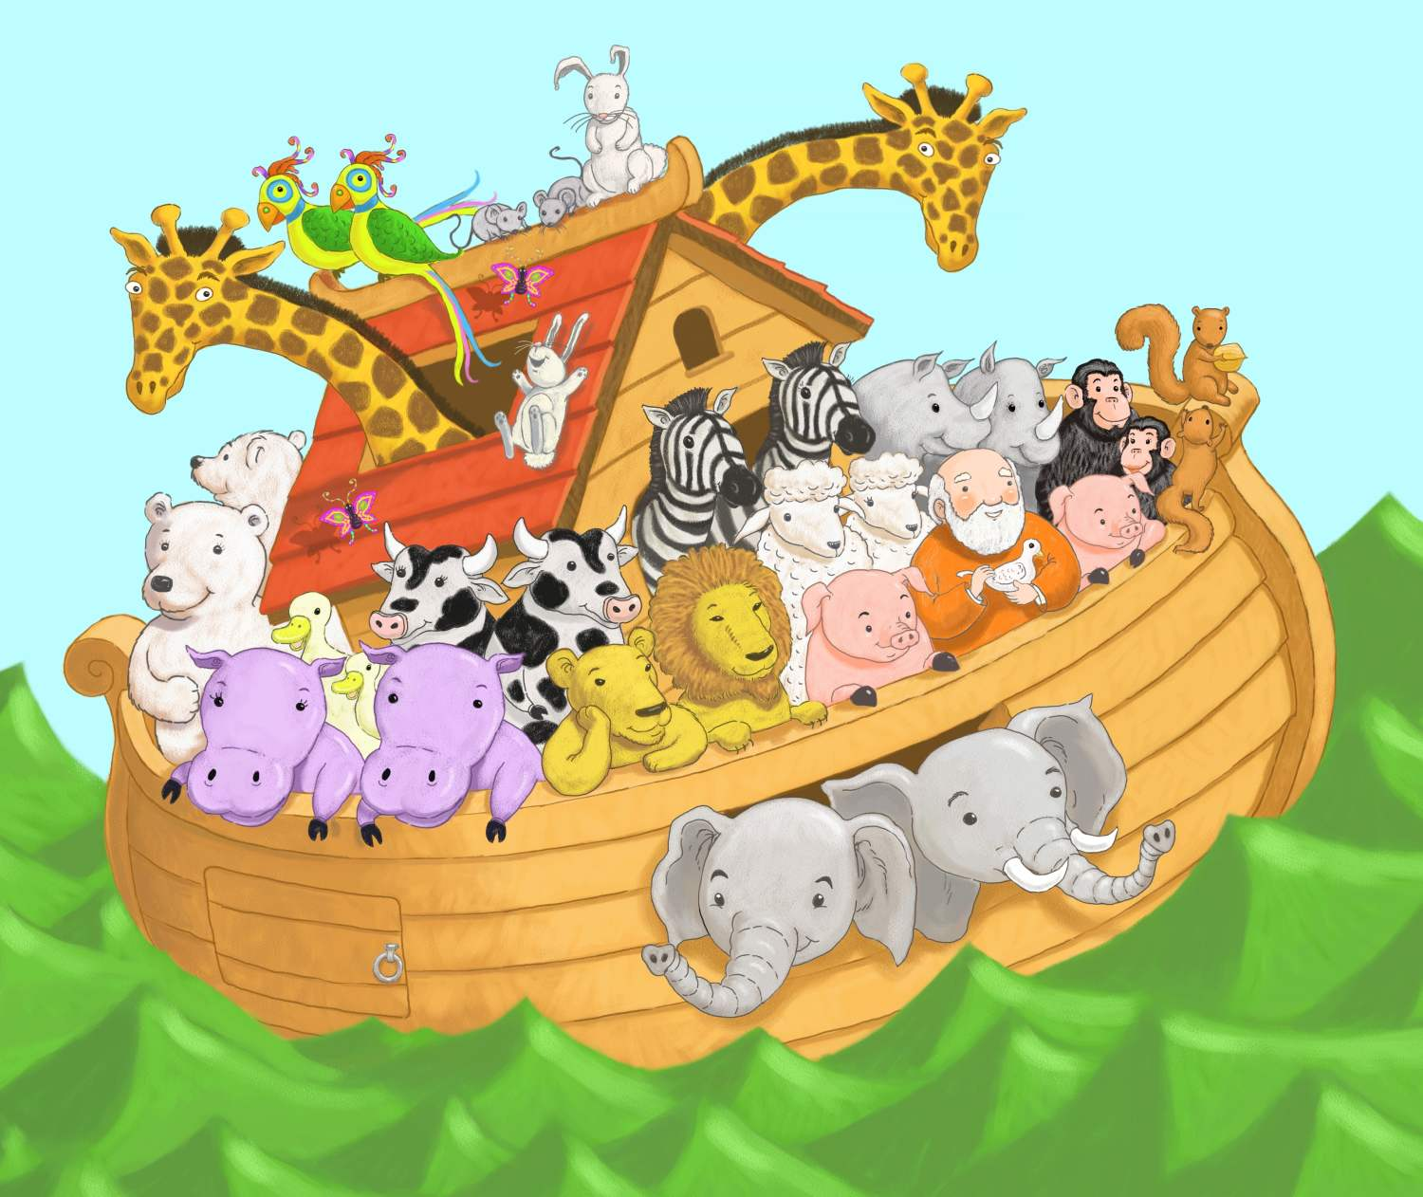
Don’t Rock the Ark
(sung to “Old McDonald had a Farm”)
Mister Noah Built an Ark
Splish Splash Splish Splash Splish
And on his ark he had two cows
Splish Splash Splish Splash Splish
With a moo, moo here
And a moo, moo there
Here a moo, there a moo,
everywhere a moo, moo
Mister Noah Built an Ark
Splish Splash Splish Splash Splish

Continue for other animals.

