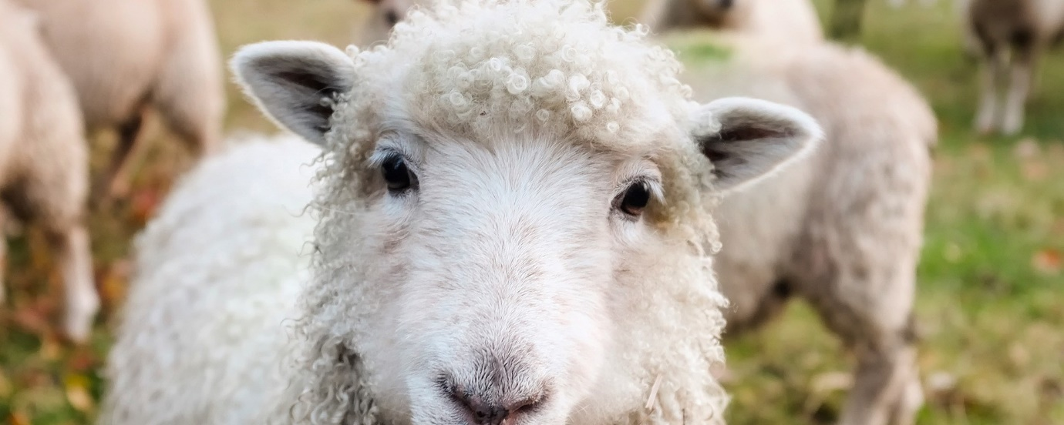Hide and seek sheep

Tell your child/children to run and hide somewhere in the house or garden. One child or adult will be the Shepherd and as the Shepherd finds each "sheep", they will be brought back to a gated area for the sheep to stay until the end of the game. When the "sheep" are found, they can "baa baa" while waiting for other "sheep" to be found and put in the gate (the "gate" can be formed with chairs or even colored tape on the floor, etc).

