Action Story: The Feeding of the 5000
This is a Bible story that involves children performing an action when they hear different words. It is best just to practice just saying the words first, until your child is confident with the actions.
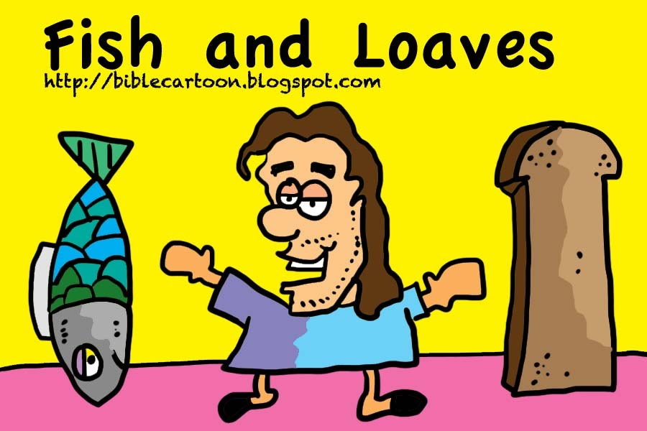
Action Words:
Food: pretend to eat
Little boy: say “aaaawww”
fish: pretend to swim

One day Jesus said to his friends ‘”We have been so busy let’s go somewhere quiet where we can have a rest.
So Jesus and his friends got into a boat and sailed away from the towns to an out of the way place.
But lots and lots of people heard where they were going and followed them!
When Jesus saw the crowds he forgot all about having a rest and he spent the whole afternoon telling them wonderful stories.
It came to evening everyone was getting hungry.
How could Jesus feed such a huge hungry crowd? It’d take a whole year of working to pay for all the food.
Then Jesus asked them, well what food do we have? And they showed him the lunch that a little boy had given to share around. There were 5 bread rolls and 2 fish. How can we possibly feed over 5000 people with only 5 bread rolls and 2 fish from a little boy’s lunchbox?!
But Jesus gratefully took the food, gave thanks to God and told his friends to start handing it out to the crowd. They were amazed when everyone had managed to eat as much as they wanted. It was amazing!

Jesus was a very clever man who cared about people. Have a look at some things that you can do to show that you care about other people.

