Make A Family Cross

Think about crosses that you have seen at home or in school. For example:

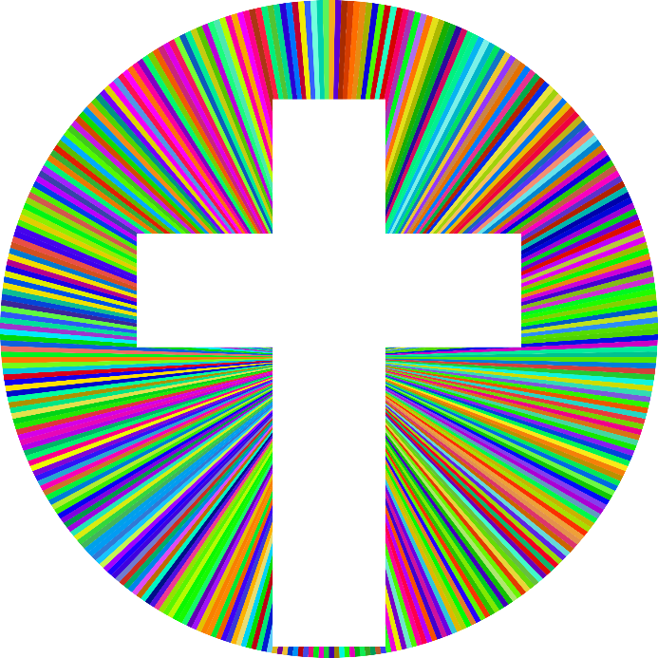

• An ‘add’ sign in Maths

• A kiss on a birthday card
• On a poster for an event that has been cancelled
• A crossroads sign on the road

Of course, a cross is the main symbol of Christianity because of Jesus’ crucifixion. Christians believe that Jesus' death allowed people to be forgiven when they do wrong things. They also believe that Jesus was resurrected (came back to life) after three days. Because of this, the cross is a symbol for Jesus' sacrifice and suffering, but also a symbol of hope and forgiveness.
There are several different Christian crosses that are symbols for different Christian groups or persons. A cross with the body of Jesus on it is called a crucifix. Christians especially remember the death of Jesus on the cross on Good Friday every year.

To see more crosses, have a look at the different ones on the website below which shows crosses around the world.

https://www.cofeguildford.org.uk/resources/the-resource-centre/world-crosses

Create your own family cross

Can you create your own family cross? What would you put on it? What is special about your family? What are you grateful for?

You could use some of the ideas below:
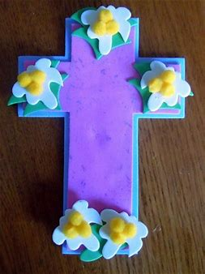
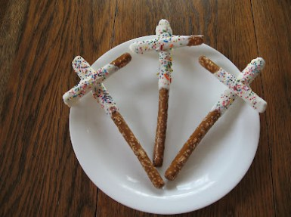

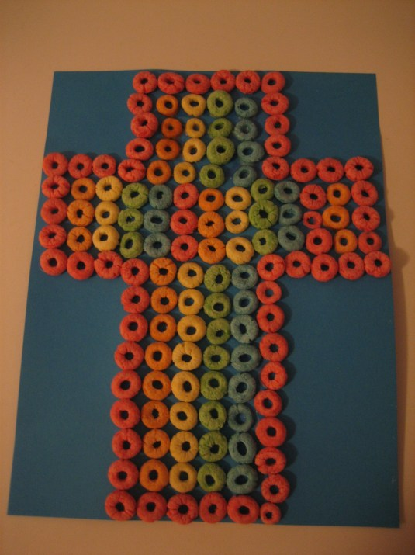
This one is made using breakfast cereal!

