Keeping calm when things are difficult
A Bible story with craft activities for Key Stage 1

Are you getting fed up at home and finding life a bit difficult at the moment? Many people across the world feel exactly like you. Noone is sure yet when life will get back to normal and that can be a bit scary. Read the Bible story below and find out what Jesus did when his friends felt scared about something. Afterwards you may like to try some of the fun activities.

Jesus calms the storm
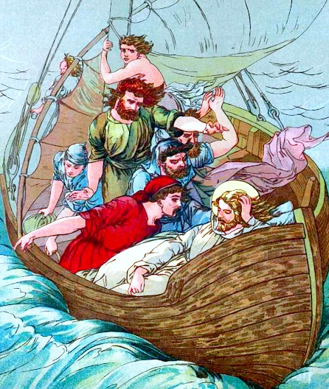
Jesus had been spending his time going from place to place, healing people and talking to people about God and the Kingdom. In one place, the crowds were so big that he had to stand in a boat off the shore so that everyone could see and hear him. He spoke loudly so that the people could hear his stories and learn from them. He knew what the people needed and he made sure to help each person.
One evening, after a long and tiring day, Jesus invited his friends to go with him to cross the lake. They left the crowd that they had been talking with and climbed in a fishing boat. After a while, rocked by the gentle waves, Jesus fell asleep.
Suddenly, the wind started to blow and a big storm began. Lightening and thunder filled the sky. Soon the waves were splashing into the boat! The boat bounced around the sea, terrifying the men inside. The storm raged but Jesus was still asleep! These men had been in boats many times and knew all about storms. They knew the sea could be dangerous and they did everything they could, but they had never been in a storm like this!
It was too big and too scary for them to handle. The men tried to wake Jesus up. They begged him to save them. They even wondered if Jesus still cared about them. They were certain the boat was about to sink and that they would all die in the sea.
Jesus helped them at just the right time. He is never too late. When Jesus woke up, He spoke to the waves, saying, “Quiet! Be still!” With just his word, the storm was gone and the sea was calm. There were no more waves. There was no more wind. The sea was smooth and quiet.

Jesus asked the men why they were afraid. They had been through hard things with him before, and he always took care of them. The big waves and their fear had made it hard for them to remember that Jesus was right in the boat with them!
When things are scary, it is sometimes hard to remember the ways that Jesus has cared for us the past and his promise to take care of us every time. That’s ok. Jesus loves us anyway and will always remind us, just like he reminded the men in the boat.

What are some situations in your life that feel like a storm right now? What are the ‘storms’ Jesus has helped you through before?
How do you think we can we trust Jesus when we feel afraid?

Time to get crafty!
Make a boat
This is just one idea, it depends what you have in the house,
Lay a milk or juice box on its side and cut along the edges of the top side of the carton with a utility knife to remove the panel and create the open top of the boat. This is the boat's basic shape. An adult may need to help you with this.
Wrap the boat, inside and out, with masking tape, tin foil or white paper to make it paintable.
Cut a triangular sail from white paper and use selotape to attach it to the dull end of a stick or skewer like a sail. Decorate the sail with crayons or felt tips.
Wrap a small box in white paper or silver foil and glue it flat inside the bottom of the boat (this will be your cabin.) Allow the glue to dry for 30 minutes.
Insert the pointed end of the bamboo skewer into the small box, but not through the bottom of the boat!
Paint or colour the entire boat. Let the paint dry before using the boat on water! Now sail you boat in your bath or sink. Make a storm like the one in the Bible story. Can you make figures for your boat and act the story out.

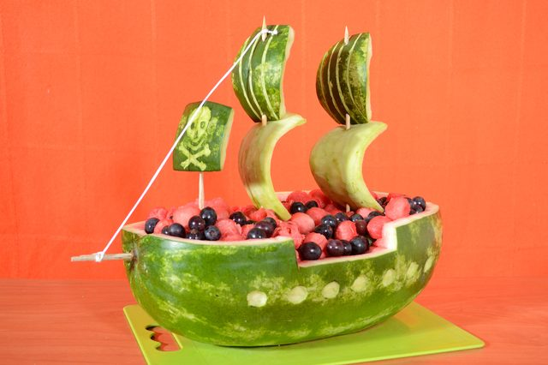
Snack
Look at this spectacular boat made using different foods.
Have a go at building a food boat of your own. Potatoes, apple and cheese slices are useful. You could add crisps or pretzel sticks to make masts and sails.
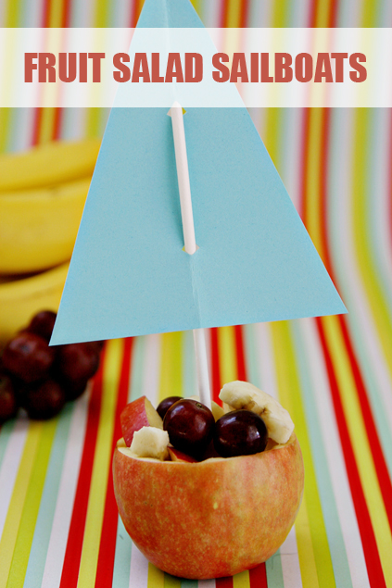
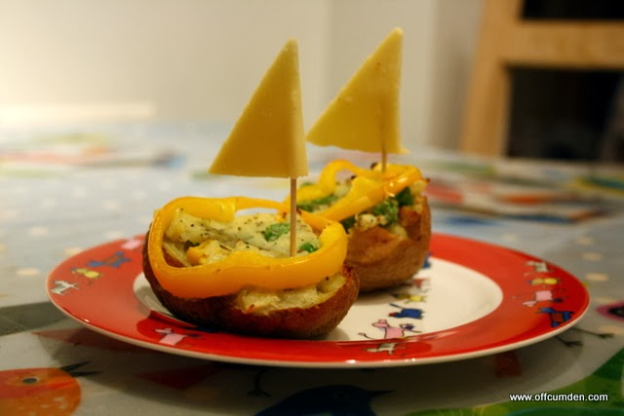

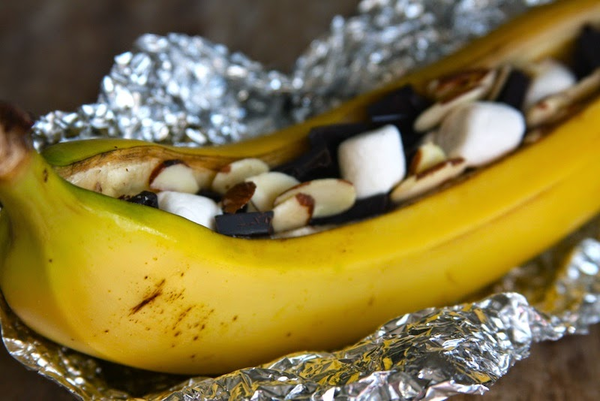

Make a storm in a bottle
In a clean bottle, clear jar or drinking glass, add coloured water to fill to about a third. To colour the water, If you have some, you can use blue food colouring, paint or whatever you have at home (an M&M or Smartie soaked in water adds colour.) Then add baby oil or cooking oil to another third. The top third is to leave room to avoid spills. Add glitter or pepper for fun.

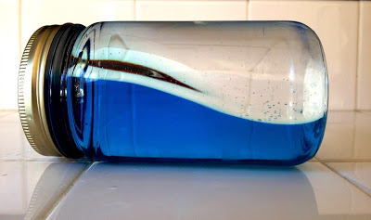
Now you can make your own waves or storm by tilting the bottle from side to side. Notice that it takes a little while for your storm to calm. The Bible says that when Jesus said, "Quiet! Be still," the wind died down and the sea was completely calm. See if you can retell the story using your bottle.

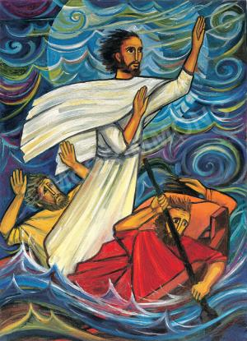
Wave technique
Look how the artist in this picture has used curls to draw the rough sea. This is a simple technique to draw something quite difficult.

If you have paints at home, you could also use them or some crayons to draw the scene of Jesus calming the sea in two pieces of art- one with the storm, one with calm water. You could even draw your picture on the same piece of paper, using both sides.

