**To           :              Headteachers**

**CC           :              Chairs of Governors, Foundation Governors, ex-officio clergy**

**From     :               Jeff Williams**

**Date      :               29th April 2020**

Dear colleagues

**Days & Calendar** : I’m hearing from so many friends and family, like the majority of people who are not able to leave home to go to their place of work, or social venues, that time and days are beginning to merge. Last week I saw on social media photo of a clock that had days, rather than minutes and hours on it, and a post that said : “Until further notice, days of the week are now called, thisday, thatday, theotherday, someday, yesterday , today and nextday”.  Typical British humour, and such things keep us connected and smiling during times that are deeply serious, concerning and often very sad.

I am delighted to commend to you the attached Bitesize Bible / Calendar that Sue Bowen our Schools’ Advisor has put together. It’s a really lovely resource, suitable for adults and children, exploring a Christian Value each month – with inspirational quotes about their faith from Usain Bolt, Desmond Tutu, Lewis Hamilton, Bear Grylls, Justin Bieber and many more. Do feel free to forward this widely – and why not start using it from May 1st – it will add structure to your days, whatever your call them!

**Message to & from** : I received a 50 second video clip from one of our Headteachers this week – and attach it for you to ponder, particularly given our focusing on time, the present and importantly, the future. The clip is attached and called ‘Letter to God’.

**England’s Biggest Assembly :** **Tomorrow Thursday 30th April at 10am**, the Archbishop of Canterbury, Justin Welby, will deliver a message of hope to school pupils across the country in the first assembly at Oak National Academy. The Archbishop’s address will be streamed through the Times Educational Supplement Website [www.tes.com](http://www.tes.com)  and will then remain available on the Oak National Academy website. www. <https://www.thenational.academy>  Do try and watch it live, and encourage your networks, families and children to watch it live, as you and they may be potentially part of a **Guinness World Record!**   
  
In addition to the assemblies, the Church of England is also partnering with Oak National Academy to provide separate weekly collective worship sessions led by schools, which will be accessible to those of all faiths and none. This will be part of the National Church of England’s forthcoming **#FaithAtHome** programme, which also launches tomorrow.

As well as the Archbishop, the first assembly will feature the Secretary of State for Education, Rt. Hon. Gavin Williamson MP.   Thursday’s event is expected to be the biggest school assembly ever held in the UK – even the world.  
  
**School Worship continues across our dioceses :** many of you are creatively leading worship to continue engaging with children and families. I’ve shared some of the ways this is being done – through interactive web pieces, videos and musical join-ups. For those who are thinking about this, the following may inspire you : At Steep Primary they have weekly video worship from members of the community as well as a website page with the weekly focus for thoughts and prayers. [https://steep.hants.sch.uk/hants/primary/steep/site/pages/homework/collectiveworship](https://url6.mailanyone.net/v1/?m=1jRET6-0008aG-4L&i=57e1b682&c=kgptFyaofh6VdCtNEA0cJLF5ZYsK2UKZVV0nHlH4B9S4_X6XtswcszMK55Ax0PBCNt8DCIGbRmhkq_-xzqj-CN0y9LKlwooSObjOKFxfc4s3Lft7lr4QrbAVI-elmNZT91lkr5TRjADXoVacomjSLi4oN8il4cf3zxBnp9Sl8VFgRjT6b_EOkK5Ge4UQeaQyxzLnGVu3B3t7v5uEAuORDqoxfAgtyh88m7d63lCN7lUL65ta_m_Kg3jx4Ew3LOIQY_VK7m9qYh5q7nBzAMZsuNydSqm5Q1hfjmTYvKsW0Uc)  and at <https://youtu.be/6S0Lu-X66Ic>

**School Values at Home :** We know if our school values are real impactful when we see them embedded in the mindset and actions of our children and community. Expressing and living-out school values at home, especially at this time, is what we all encourage. At Medstead Primary, Headteacher Jane Oborn has asked parents to continue to award ‘Gemstones’ and certificates are sent via the Newsletter. Do enjoy this video the school has made : [https://www.medstead.hants.sch.uk/home-learning/](https://url6.mailanyone.net/v1/?m=1jTNuY-0006TW-5h&i=57e1b682&c=kqPKdmmockc_RNCP_PZOtsQ5uy4brvGF8j45u8e8t3mrzJHNj9jRGXLTVIj8C1HxW6VzstX5VGXaZ93APVBmhoF_67wG1qjEBW-Akq2Dz5ArD03A8bepxE-8jWPkhWOqCwf1Z-tGCRrtf1lRFmw0vxYveyMRrX217dHNlS7JFOidZiX9mDd3PiSe8CgWxtBgypL2-MuAEpwzt2bcH4HUorgalTKBBrXIXae6ZaA0x9fjQb9M7AyB32ZodwNC2NxX)

Jane has suggested that parents can reinforce Medstead’s four school values, for example by : **Trust:** Completing some Remote Learning they understand independently once you have set them off, even for say ten minutes if your child is young or you’re building up their independence; Paying someone in the family, particularly a sibling, and a compliment or saying something supportive to them. **Courage:** Talking about their feelings; Having a go at some Remote Learning they are finding tricky. **Hope:** Making plans, including for a better world and how this pandemic could change things for the better; Keeping in touch with friends and relatives. **Resilience:** Persevering with some Remote Learning; Helping with household chores.

**Bedtime Stories** : we’ve had a fantastic response to the Bedtime Story suggestion. Pyjamas are clearly and understandably not for all, but do check out some of our schools who have embraced this way of keeping children connected and reassuring them. Andy Poole, Headteacher at St Clement’s and St John’s Infant School reads Mr Big <https://www.youtube.com/watch?v=nZLtaC0gq2I> while Tim Clarke, Headteacher at Cornerstone Primary reads Hairy Maclary and Chocolate Cake [www.cornerstoneprimary.hants.sch.uk](http://www.cornerstoneprimary.hants.sch.uk) and Jon Le Fevre, Headetacher at Pilgrims’ Cross reads his favourite book, The Gruffalo <https://url6.mailanyone.net/v1/?m=1jREEK-0001xm-5Y&i=57e1b682&c=Y3LLL_FzsdRLyOWgoNA02-BWom_pO_MtphcVujehuJNosbLJVJJyWeNBSZcyyDvXfuAz31lOir-u4Zk4r-7WD8E-SLbYHkrySKrmLt0n5uZrDYTpbc4XCKmnfEeEhjEBKlKVYHGp8JzGl8IrJAF-9G9f4lRhWYUSJ7-5DjKH2Jna7ZIEsm7LME3uOyS6hou_OwuCPaJ6Bt_tt9kEl7OHKTedtGzdedjCzK85lYatGCs>

In addition to their bedtime stories **Staff at Burton Primary** were featured in the Bournemouth Echo having made a video of teachers and others dancing to ‘Reach for The Stars’. The article is attached and videos are on the school’s website at <https://www.bournemouthecho.co.uk/news/18394917.primary-school-teachers-join-dance-video-lockdown/> Bedtime stories : <https://burton-ceps-redesign.primarysite.media/media/spreading-a-bit-of-happiness-to-all-our-children-a>

**Liverpool Hope University online Governor Training Programme**  - The Anglican-Catholic University programme is aimed at Governors and Trustees (Directors) in both church schools and schools with a distinctively Christian ethos, providing support for Governors and Trustees (Directors) committed to improving provision and outcomes for children and young people. Significant discounts available for groups of governors from the same Diocese. Attached is their flyer

**Titanic at Southampton’s Sea City Museum :** There’s a virtual tour of Southampton's Titanic Story at Sea City Museum where you can also find a range of free online resources to keep learning at home fun, including activity packs to discover more about the RMS Titanic, the Mayflower and more at : <https://seacitymuseum.co.uk/online-activities>

**Resources :** the engaging resources that Sue has produced on a weekly basis have been very much welcomed by colleagues. Do open this week’s that are attached  – as ever, they appeal to adults as well as children (Standing Together in song particularly speaks – sorry, sings, to me as a Welshman!). There are lots of attachments – knowing that some are selected by ministers to forward more widely, some by recipients to their families and friends – so please check them out. I’ll be sending separately versions of many of the resources we’ve shared that have been re-written and adapted to focus on Early Years / Nursery settings.  Also, with gratitude to **St James’ School, West End** – re-worked versions of activities for Year 2 & Year 3 Winchester children (and families!) on Rwanda, and for Year 2 & Year 3 Portsmouth children (and families!) on Ghana – all to follow separately.

**Home Learning in England and Home Learning in Rwanda** : Three Headteachers, Sue and I had a zoom catch up with our Rwandan friends last week. The majority of children that we have taught and know live in remote rural areas, with no TVs and no internet. The challenge for our Headteacher colleagues in Rwanda at the moment is getting messages to families that there is some Home Learning available on the radio. Social distancing, hand washing and availability of food and money are seriously affecting the population. They remain positive and joyful for what they have, but it brings home how blessed we are, even when we might be overwhelmed and tired of our drastically changed lifestyles.

and finally – some lovely photos below of pupil **Sophie Rawlinson, from St James’ Primary, West End**, using home learning time baking Mandazi, a traditional Rwandan snack. It’s delicious – why not give it a go?! Please would you seriously consider engaging in this and send me photos, so I can share with our Rwandan friends, who really appreciate knowing that we remain connected and that they are not forgotten. Your photos bring them joy and hope.

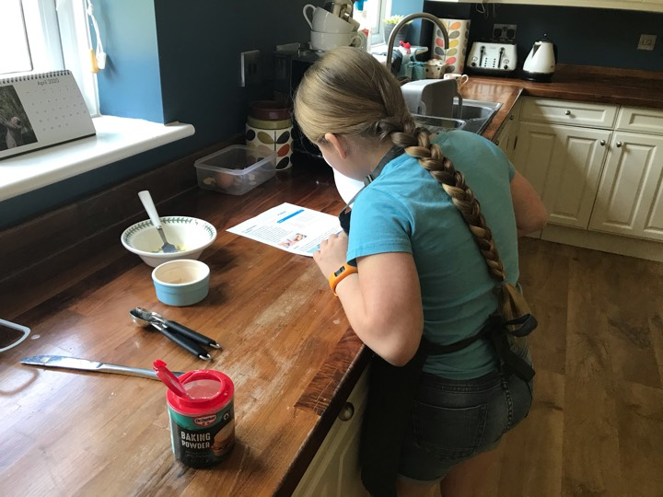

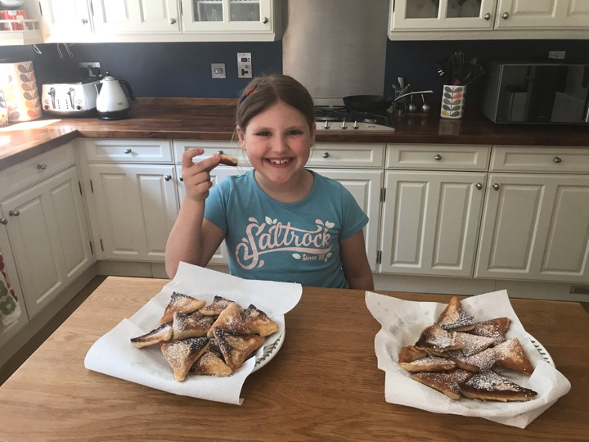

A continued thank you for all you are doing and being.

Best wishes

**Jeff**

Jeff Williams

Director of Education

Diocese of WINCHESTER &

Diocese of PORTSMOUTH

| t: 07841 020836  | Personal Assistant : [Sam.powell@portsmouth.anglican.org](mailto:Sam.powell@portsmouth.anglican.org) t: 02392 899680   
|[www.winchester.anglican.org](http://www.winchester.anglican.org/)|[@CofEWinchester](https://twitter.com/CofEWinchester)| [www.facebook.com/CofEWinchester](http://www.facebook.com/CofEWinchester)|[www.portsmouth.anglican.org](http://www.portsmouth.anglican.org/)

|Diocesan Office, Peninsular House, Wharf Road, Portsmouth PO2 8HB|Diocesan Office, Old Alresford Place, Old Alresford, Winchester SO24 9DH|