Divine Chocolate National Poetry Competition
Get creative and write a poem about cocoa and chocolate!
We run the annual Divine Chocolate Poetry Competition, now in its 18th year. We have categories for children and adults.
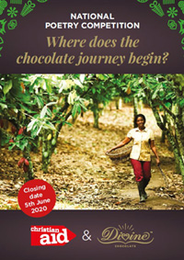
This year's theme: Where does the chocolate journey begin?
Here are some ideas to tackle the theme:
Cocoa grows on trees
The key ingredient in chocolate is cocoa. Most of the cocoa you eat comes from the rainforests of West Africa, where poor farmers tend their cocoa trees on small family farms. This is where the chocolate journey begins.
The journey through history
Among the Mayans and Aztecs of Central America where cocoa originated, cocoa beans were so important they were used as money. Nobles drank cocoa at royal feasts. In modern times, chocolate has come to symbolise romantic love and luxury.
From bean to bar
Cocoa comes from the seeds of cocoa pods, which grow on the cocoa tree. Farmers harvest the cocoa, ferment it and dry it out in the sun, and then send it to factories to be made into delicious chocolate.
Into the future
Changing weather patterns make it harder to grow cocoa, driving cocoa farmers to move and cut down the rainforest for new farms, which makes climate change worse. Through Fairtrade, we can support cocoa farmers to farm in a better way and protect the forest.
Want some inspiration about cocoa and the rainforest? Watch our short film Guardians of the Rainforest.

How to enter the Poetry Competition
The closing date is: 5th June 2020
Upload your poem here
Remember this is the Divine Poetry Competition – if you write about chocolate products, don’t write about other chocolate companies!
The winners will be decided in June by a judging panel including guest judge Onjali Raúf, author of The Boy at the Back of the Class, a story of friendship, hope, and the importance of kindness.

Are there prizes?
Yes! You get a film of your poem being read by this year's guest judge, Onjali Raúf, winner of the Waterstones Children's Book Prize 2019. You get book tokens. And lots of delicious Divine Chocolate goodies!

